**Online Campus Course Portal**

**By**

**SAIYAM SHAH**

**17BIT104**

**KARAN SHETH**

**17BIT105**



**DEPARTMENT OF INFORMATION TECHNOLOGY**

**Ahmedabad 382481**

**Online Campus Course Portal**

**Mini - Project**

Submitted in fulfillment of the requirements

For the degree of

**Bachelor of Technology in Information Technology**

By

**SAIYAM SHAH**

**17BIT104**

**KARAN SHETH**

**17BIT105**

Guided By

**Dr. Smita Darandale**

**DEPARTMENT OF COMPUTER SCIENCE AND ENGINEERING**



**DEPARTMENT OF INFORMATION TECHNOLOGY**

**Ahmedabad 382481**

CERTIFICATE

This is to certify that the Project entitled “**CAMPUS ONLINE COURSE PORTAL**” submitted by SAIYAM SHAH (17BIT104) and KARAN SHETH(17BIT105), towards the partial fulfillment of the requirements for the degree of Bachelor of Technology in Information Technology of Nirma University is the record of work carried out by him/her under my supervision and guidance. In my opinion, the submitted work has reached a level required for being accepted for examination.

Dr. Smita Darandale Dr. Madhuri Bhavsar

Assistant Professor Professor and Head of Department

Department of Computer Science and Department of Computer Science Engineering, and Engineering

Institute of Technology, Institute of Technology,

Nirma University, Nirma University

Ahmedabad Ahmedabad

**ACKNOWLEDGEMENT**

We would like to express my deepest appreciation to all those who provided me the possibility to complete this report. We acknowledge with thanks, the support rendered by Dr .Smita Darandale, under whose aegis we were able to complete the task in a given period of time. We also appreciate the constructive suggestions given by my friends to further enhance content of the report.

At the home front, we are extremely grateful to our family members for the support and encouragement, we got from them in successfully completing the report.

**ABSTRACT/ Outline**

In our project we have made campus online course portal, The main goal of Our Online Course Portal is to build on the engineering and core science courses. An additional video courses were created in all major branches of engineering, physical sciences at the undergraduate and postgraduate levels and management courses at the postgraduate levels and management courses and management courses at the postgraduate level. Several improvements such as indexing of all video and web courses and keyword search will be implemented in future.

CONTENT

Certificate I

Acknowledgement II

Abstract III

Table of Contents IV

List of figures

Fig 5.1 Class Diagram of Project  11

Fig 5.2 Use Case Diagram of Project 13

Fig 7.1 Sign page of Online Course portal 16

Fig 7.2 Home Page 17

Fig 7.3 the Course Allocation Page for enrollment of course 17

Fig 7.4 Course Allocation 18

Fig 7.5 Video-Quiz Window 19

**1 Introduction 8**

1.1 Purpose 8

1.2 Product Scope 8

**2 Operating environment 8**

2.1 Operating System 8

2.2 Software Requirements 8

2.3 Hardware Requirements 8

**3 Functional Requirements & Interfaces**  **9** 3.1 Functional Requirements 9 3.1.1 Sign-In of Login Window 9

3.1.2 Home Window 9

3.1.3 Course Window 9

3.2 Software Interfaces 9

3.3 Communication Interfaces 9

**4 Non-Functional Interfaces 10**

4.1 Performance Requirements 10

4.2 Security Requirement 10

* 1. Software Quality Attributes 10

**5 Preliminary Design 11**

* 1. Class Diagram 11
  2. Use Case Diagram 12

**6 Implementation 12**

6.1 Database Creation 12

## 6.2 Basic Data Classes 13

## 6.3 Database Connectivity Using JDBC 14

## 6.4 GUI Programming using JavaScript14

**7 GUI Windows 15**

7.1 SignIn-Login Window 15

7.2 Home Window 15

7.3 Course Description Window 17

7.4 Video-Quiz Window 18

**8 Summary and Conclusion 19**

8.1 Summary 19

8.2 Conclusion 19

**References 20**

**Appendix A – List of Useful Websites 21**

# 

# 1 Introduction

## **1.1 Purpose**

This document reports the functional and non-functional requirements of our project ‘Online Campus Course Portal’. It gives a description of the software’s scope as well as its requirements and constraints. Subsequently, it showcases the various modules designed using JavaScript, HTML, JQuery, CSS and PHP.

## 

## **1.2 Product Scope**

This website is to be used as tool to attain the various courses which are been provided in course portal. Here the particular student had to select the courses for which he wants to enroll and after that for each course we have made the whole syllabus plan and for each particular subtopic there is a quiz and for each course subsequent faculty is being assign to analyze the quiz marks.

**2 Operating Environment**

2.1 Operating System

• Windows 7 or Higher

2.2 Software Requirements

• HTML, CSS, JAVASCRIPT

• Local MySQL Server

2.3 Hardware Requirements

• RAM: 200 MB

• Disk space:

• 124 MB for XAMPP Server;

• 500MB for the Product;

• 500MB for database.

• Processor: Minimum Pentium 2 266 MHz processor.

• Browsers: Internet Explorer 9 and above, Firefox, Chrome

# 

# 3 Functional Requirements and Interfaces

## **3.1 Functional Requirements**

The Functional requirements outline the minimum tasks the product will be capable of performing. Later version may see additional requirements added as the responsibilities of the product are further refined.

### 3.1.1 Sign-In of Login Window

On the validation page it would ask you your details such as your username which will help to do registration in the website and will be helpful for the further process.

### 3.1.2 Home Window

On the Home page it will show all the functionality which the user can use for its project, such as for the course registration and about us and also feedback can be given by the user.

### 3.1.3 Course Window

The User will click on each course to enroll course he wants to do and a alert box will be shown to him for each successful registration, also it contains the description of each course which can be viewed at the sidebar.

## **3.2 Software Interfaces**

* Local MySQL Server: The database will interact with the product by responding to queries from the product using SQL.

## **3.3 Communication Interfaces**

The product will initially run locally, and the database will be stored on the client machine for the initial version. Later versions may see the database on a remote server and accessed using the HTTP protocol.

# 4 Non-Functional Requirements

## 

## **4.1 Performance Requirements**

Startup of the software must be fast and data retrieval should not take more than a few seconds. One thread handles GUI, another takes care of data reads and writes and another thread may be used for handling errors and exceptions.

## 

## **4.2 Security Requirement**

Care needs to be taken to prevent unauthorized changes in student course details by malicious entities in the database. This may be done by using an additional layer of user authentication, perhaps using an id and password.

## 

## **4.3 Software Quality Attributes**

The product will need to be visually appealing and must include an intuitive, easy-to-use design. The user must understand every aspect of the product by just looking at the relevant UI elements.

# 5 Preliminary Design

The preliminary design phase of the project involved creating the following UML diagrams using the open-source UML modeling software UMLet.

## 

## **5.1 Class Diagram**

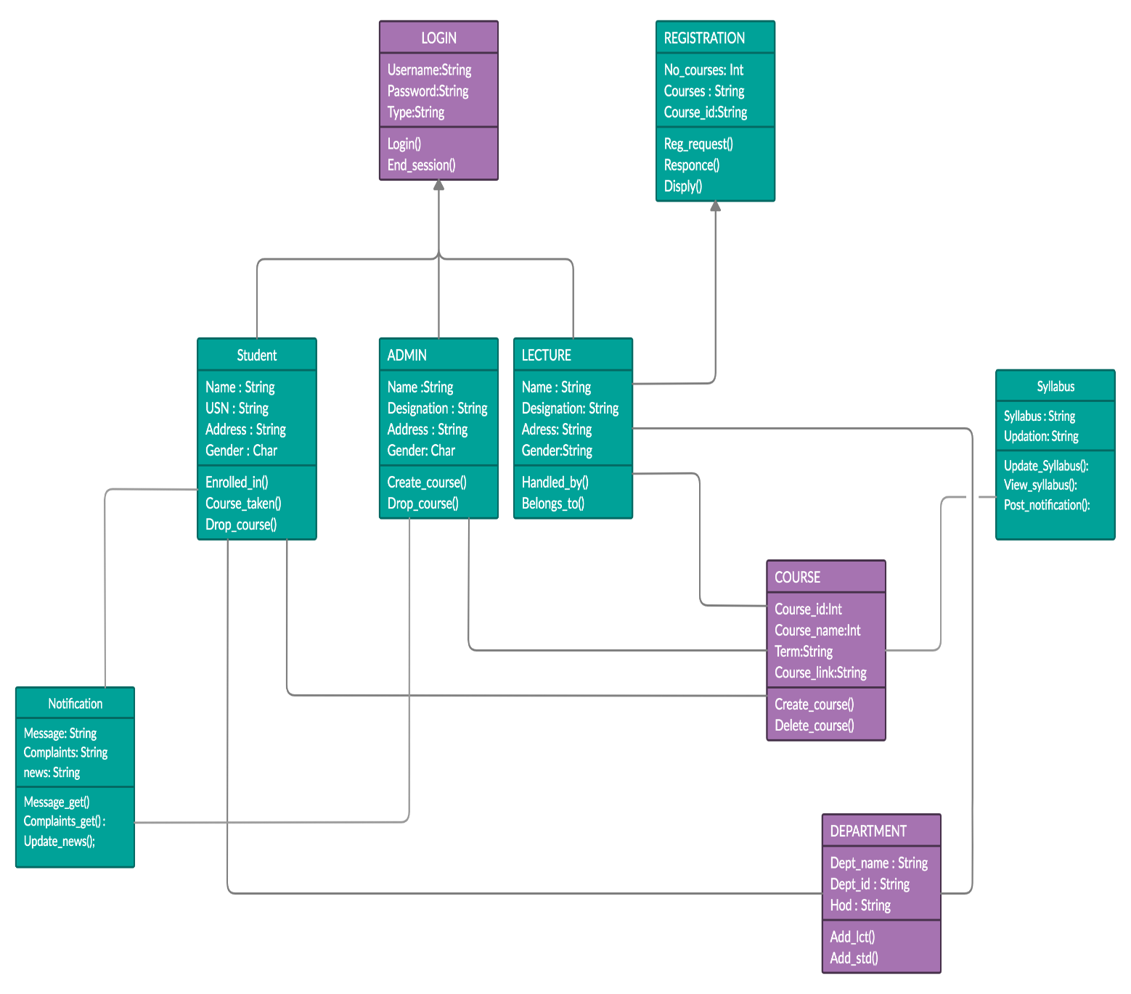

*Fig 5.1 Class Diagram Of Project*

**5.2 Use Case Diagram**

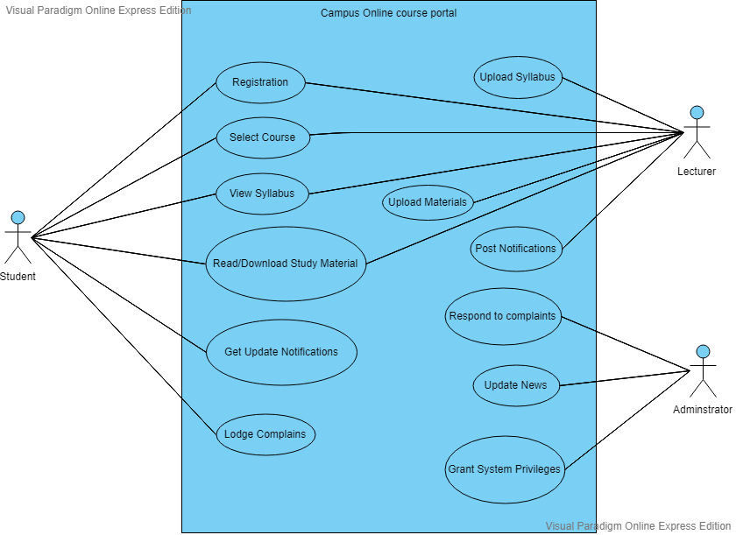

*Fig 5.2 Use Case Diagram of Project*

# 6 Implementation

## **6.1 Database Creation**

MySQL has been used for data storage. However, the admin can choose any other database management system of his/her choice. We have made two databases in which data of first database is retrieved and used in making of second database. The database includes the following tables:

1. UserName: It will have Username of each Student.
2. Email-Id: It will have email-id of the each Student.
3. Courses: It will include information about which Course which are been taken by the Users.
4. Password: It will store the password for each username.

## **6.2 Database Connectivity using JDBC**

In order to connect the database to the application, Java provides Java Database Connection Drivers. The package java.sql has been imported in order to access the classes present in it for connecting the database. The class used for connection has been named as DatabaseConnection wherein an object of Statement interface “stmt” and an object of Connection interface “con” have been made. First, the class associated with the URL is retrieved using the forname(String URL) method of the class ‘Class’.Thereafter, the method getConnection(String URL, String root, String password)of class DriverManager has been called which, on establishing connection, returns it to con. A statement is created by the createStatement() method called by con and the resultant statement object is return to stmt. Two methods, getCon() and getStmt() are created which return con and stmt respectively. The method queryDatabase() is used for executing the queries which returns a ResultSet object while updateDatabase(), as the name suggests, updates the database.

## **6.3 GUI Programming using JavaScript**

In order to create GUI applications with less programming and more visual effects, JavaScript has been used. JavaScript is a client-side programming language which helps web developer to do  Web Application Development and make dynamic and interactive web pages by implementing custom client-side scripts. Developers can also use cross-platform runtime engines like Node. js to write server-side code in JavaScript..

# 7 GUI Windows

### 7.1 SignIn-Login Window

This Registration Window consist of exactly two buttons and a form . There are of Sign up button and other one is of Sign In button. The Signin button functionality is to add the User details into the database where mysql is being processed in the backend, While the other button is helpful to go the the signin page if a user is already registered in the system.

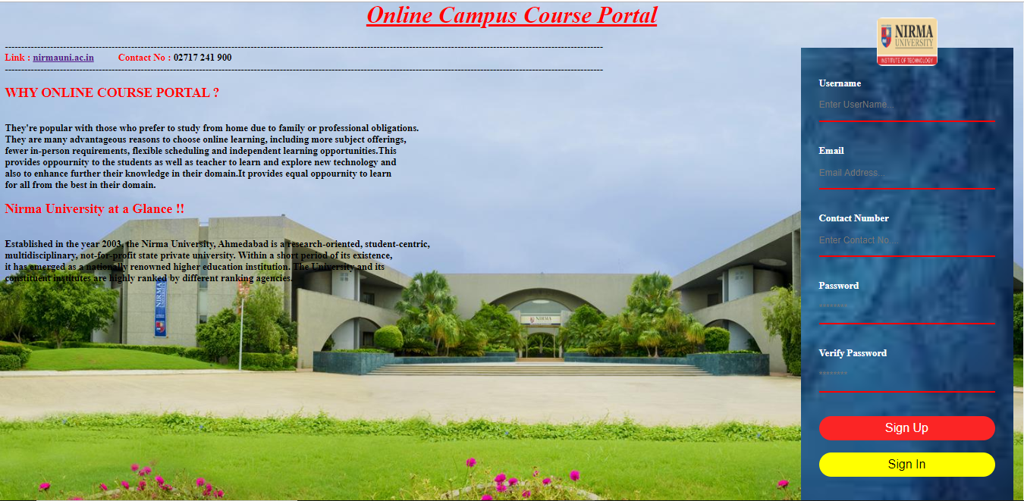

*Fig 7.1 Registration page of Project*

**7.2 Home Window**

This Home window will be open when the User sign in with his account, (button is been clicked by the user on that signin page). On the Home page it shows all the functionality which the user can use for its course, such as for the course registration and about us, feedback and he also can see his profile and the list of courses which he had selected, and the rest is just the information of the college.

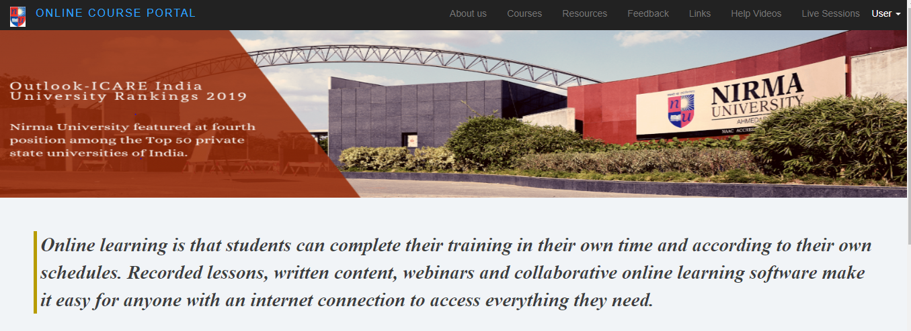

*Fig 7.2 Home Page*

whenever you click the Course button From the <li> tag list, It will generate to you the page as shown in fig 7.3, where you can see the description as well as enroll for the course.

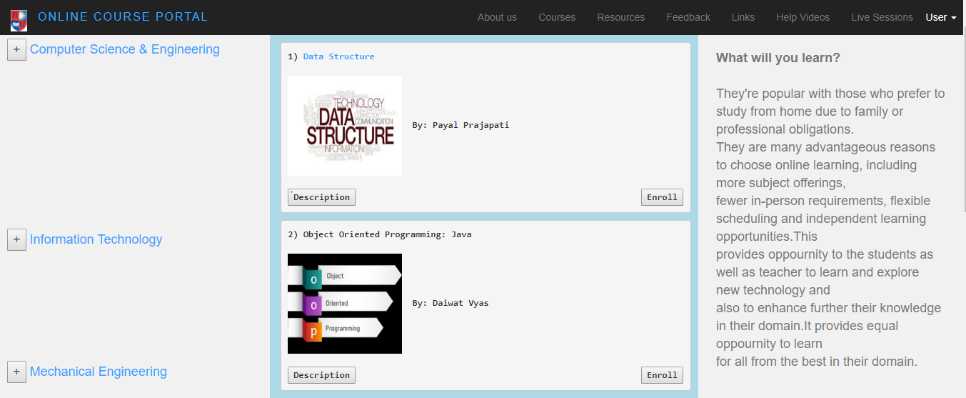

*Fig 7.3 the Course Allocation Page for enrollment of course*

**7.3 Course Description window**

On clicking that “Data Structure” Course button It will redirect the user to the course policy page of that course where he can find the subtopic which will be covered by the experts week wise.

Here the user can also click the particular subtopic where he can see the video of that subtopic as well as can attempt the quiz simultaneously,where he will get the score and will be sent to his faculty member who can incharge this.

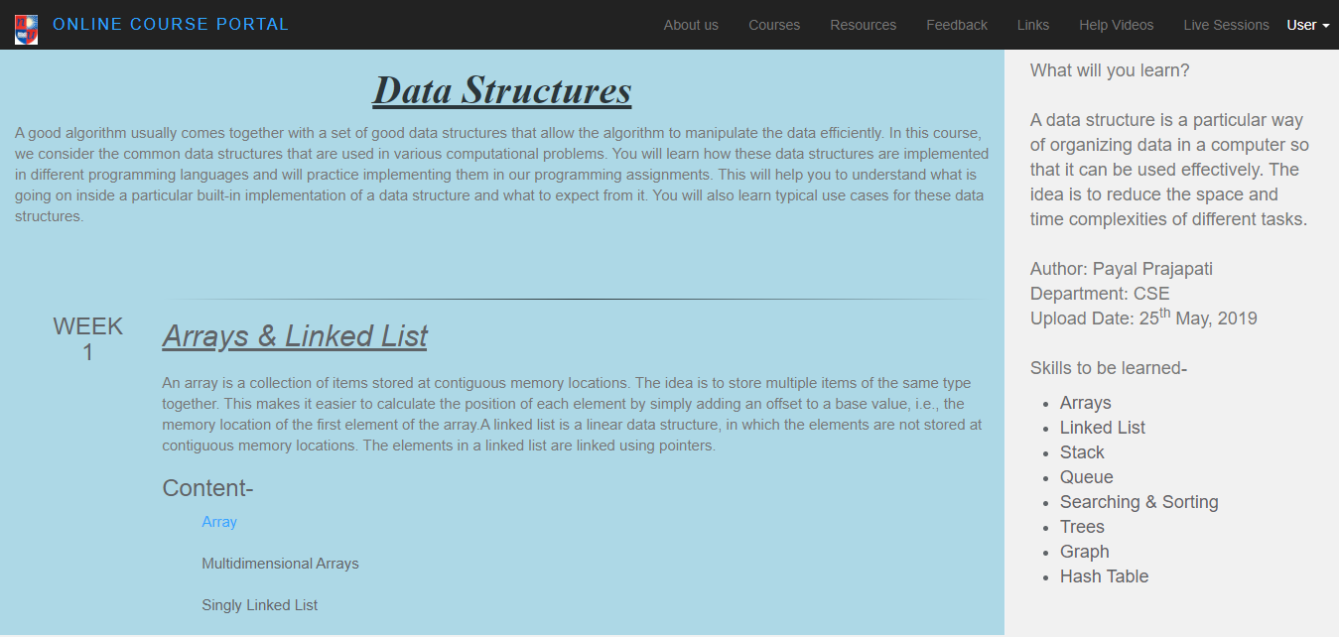 *Fig 7.4 Course Allocation*

**7.4 Video-Quiz Window**

This window is opened when the user click on the Particular subtopic where he can see the video of that subtopic as well as can attempt the quiz simultaneously,where he will get the score and will be sent to his faculty member who can incharge this.

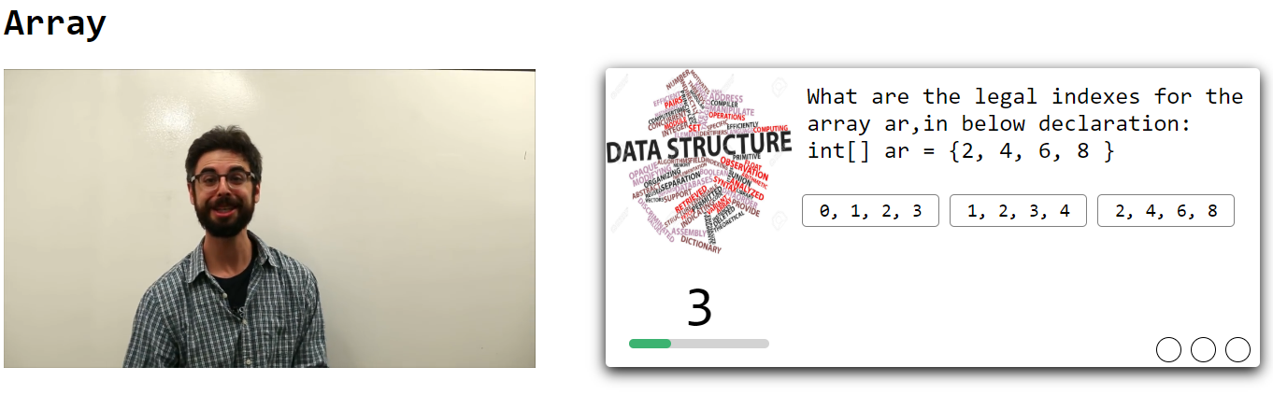

*Fig 7.5 Video-Quiz Window*

# 

# 8 Conclusion & Summary

# 8.1 Summary

In our project we have made campus online course portal, The main goal of Our Online Course Portal is to build on the engineering and core science courses. An additional video courses were created in all major branches of engineering, physical sciences at the undergraduate and postgraduate levels and management courses at the postgraduate levels and management courses and management courses at the postgraduate level. Several improvements such as indexing of all video and web courses and keyword search will be implemented in future.

**8.2 Conclusion**

To make a course portal manually by human being will be very difficult given above all constraints and also it will take lot of time so according to need it would be easy to generate this Course Portal through system like this which is user friendly, easy to implement and will save lots of time.

# References

1.       Deitel Deitel Nieto, Internet and World Wide Web: How To Program : 2nd Edition

2.       Scott Parker, Paperback, The Web Designer's 101 Most Important Decisions Professional Secrets for a Winning Website

3.       Kogent Learning Solutions Inc., Html5 Black Book : Covers Css3,Javascript,Xml,Xhtml,Ajax,Php And Jquery, Publisher: Dreamtech Press

4.       [Jon Duckett](http://www.google.com/url?q=http%3A%2F%2Fwww.flipkart.com%2Fauthor%2Fjon-duckett&sa=D&sntz=1&usg=AFQjCNF2KjVokjwJ93U45HMV1T4mYieTMA)Publisher, Beginning Web Programming with Html, XHTML and CSS, Wiley India Pvt Ltd.

# Appendix A – List of Useful Websites

1) W3Schools "CSS Tutorial"

https://www.w3schools.com/w3css/

2) W3Schools “JavaScript Tutorial”

https://www.w3schools.com/js/